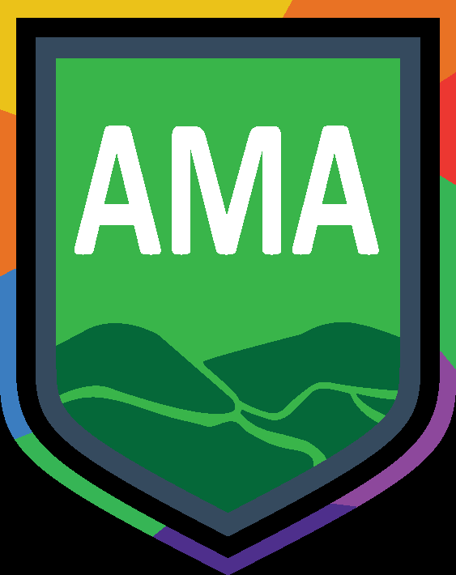

Monday 20th December 2021

Dear Parents/Carers,

In light of the current national situation regarding the pandemic Archway Learning Trust has made the difficult decision for the welfare of our whole Trust community to close on Tuesday 21st December, we will start dismissing students at 2.30pm. We hope that you will support us as we continue to try and navigate this challenging situation in order to keep staff, children and families safe at this time.

This means that schools are not open for students on Wednesday 22nd December 2021. There will be no remote lessons, however if you would like you child to access learning, please do this through Oak National Academy, https://www.thenational.academy/

We would like to remind you during the holiday season to:

- Continue to complete twice weekly Lateral Flow Tests
- Wear face masks in public spaces and public transport
- Maintain social distancing where required too
- If you are concerned with the welfare of you or anyone in your household to consult NHS or 111

We will continue to keep you up to date with developments that are announced from Public Health England and the DFE and we will communicate any future changes as early as we possibly can.

We will send further communication regarding the start of term arrangements including testing for students at the start of the new year. We recently sent a link out to obtain information regarding device access, please complete this at your earliest convenience:

https://forms.office.com/Pages/ResponsePage.aspx?id=iQyZI2eu_EqHzkcMl6_rN5GC5vNdQYNCnbQEe_z9fJBUMEZWOFlWMkRFWDVYT0hDN0VFM1BLVk9TWS4u

May we take this opportunity to wish you a restful, safe and enjoyable holiday season.

Yours sincerely,

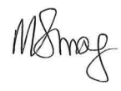

Mrs M Strong
Principal

