Keep on singing.
By Cathryn Haywood June 2020
Some back to basic skills and challenges to work on during lockdown.)
It is a long time now since we sang as a choir and WE WILL SING TOGETHER AGAIN! You will no doubt have missed the experience as much as I have but we just have to be patient and look forward to singing as a choir together again in the not too distant future.
To help you keep on track with your vocal development I have put together this pack to give you some direction and personal challenges. If you can read the music used with the exercises and play along or use a keyboard that’s great but they work without just as well
I have included links to some web sites I think are worth exploring and set you some vocal challenges too using one classic song and two modern ones.
Often to move forward it is good to go back.

Four very important basics to remember when getting ready to sing.
- The Singers Stance. This is the ideal way to stand for practise and performance. Legs slightly apart, shoulders down (relaxed), head level arms by your sides.
- Breathe deep. Use your diaphragm. High shallow breaths are useless, as you breathe in you should feel your lungs expand. (no sniffing please)
- Relax. Keep your jaw and head more or less level. Singing with the head on one side or the jaw jutting out creates tension and puts stress on your vocal cords.
- Open your mouth! Too small an opening restricts sound and the ability to project.

Try to keep doing all the above as your practise, most of you will do them without thinking because they are embedded and part of your musicianship.

Basic warm ups to exercise the parts we use to sing.
Musical menagerie (A B C) resource 1.
These notes are a guide to help you do the exercises . You will see that I have used musical notation and I have included a scale to show you the notes if you cannot remember them.
- PANT. This exercise is designed to work your abdominal muscles and diaphragm which helps you develop and maintain a good breathing.
I suggest you say it first then sing it on one breath.

- MEOW. This one is designed to use forward placement, the lips and the ear (pitch)
Pitch a note in your middle range (g on the music) and dip down and back up (g down a third to e and back up).

- BUZZ. This exercise involves resonation. Feel the vibration.
Start by counting to 12 slowly then buzz counting the same pace in you head as you do so.
Tingling is normal. If you buzz louder the tingling should be stronger. If it drives you crazy you are doing it well.

Forward placement and resonance reminder – D E F resource 2

- Mmm moh. Good singers need to be great hummers. Humming properly requires vibration and helps us to resonate.
Lips should be just touching not pressed together.
The more tingly the better.
Sing this exercise on a monotone (one note) try not to change pitch.

- Hmm mah .Singers need to be able to move smoothly from one sound to another. This exercise helps you take the resonance from the hmm into the open mouth / mah sound .
Count a slow 123,123 then count in your head as you sing mmm for 3 beats then mah for 3 beats.
Introduce dynamics by doing this exercise softly and loudly (piano and forte)

- Mee, pee, bee.
Think of this melody like three steps up a ladder 1 2 3 then back to 1 or you can sing c d e c to get them in your head and also train your ear.

Aim for a warm sound with a wave feel to it. If you hear the wave you are resonating well.
Vary the dynamics by practicing crescendos (start soft end loud and vice versa.)
Repeat the exercises aiming to keep the same quality in your sound.

WARNING - the following personal challenge is NOT EASY!

Dare to take up this tricky articulation challenge .
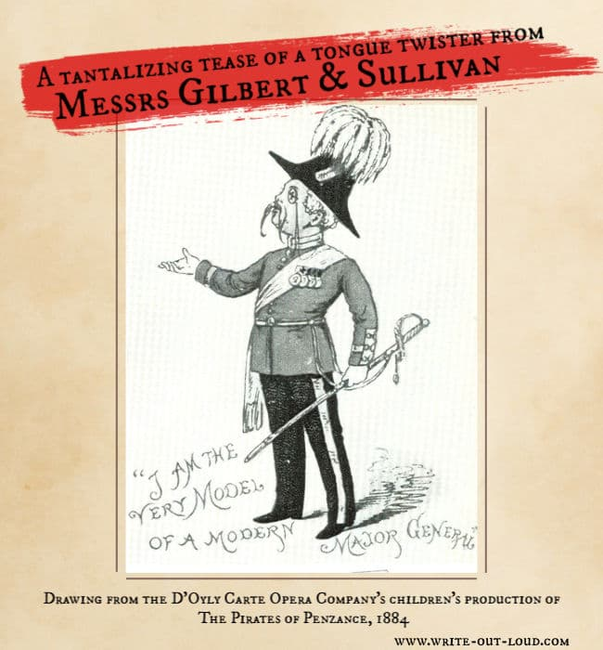
To see a perfect example of excellent articulation in practice we are going back to a song written in 1880 by the great Gilbert and Sullivan for a light Opera called The Pirates of Penzance.
The Major General sings one of the very best, tricky wording songs of all times. It’s known as a patter song and it's a triathlon for the articulators, especially the tongue!
The lyrics include lots of awkward word combinations and are impossible to get right unless you articulate clearly.
Task 1. Watch a performance of the song. www.youtube.com/watch?v=JTSpFksJ9LQ
(Alexander Armstrong performs the Modern Major General's song, from Gilbert & Sullivan's Pirates of Penzance, accompanied by the BBC Concert Orchestra (c. Steve Sidwell) and the Crouch End Festival Chrosu. Broadcast on 14th November 2016 as part of BBC Children in Need Rocks for Terry.)
It is a superb rendition and makes you realise how articulate humans can be!!!
You will probably recognize Alexander Armstrong as a T.V.presenter.
No doubt you will be in awe of the speed of delivery. The diction is superb and the breathing invisible!

Task 2. Listen /watch it again and see if you can pick out where the accents fall (which words /beats are emphasized) try repeating the first couple of lines and have a go singing alongside the singer.

I am the very model of modern Major General
'I am the very pattern of a modern Major-General;
I've information vegetable, animal, and mineral;
I know the Kings of England, and I quote the fights historical,
From Marathon to Waterloo, in order categorical;
I'm very well acquainted too with matters mathematical,
I understand equations, both simple and quadratical,
About binomial theorem I'm teeming with a lot o' news,
With many cheerful facts about the square of the hypotenuse.
I'm very good at integral and differential calculus,
I know the scientific names of beings animalculous,
In short, in matters vegetable, animal, and mineral,
I am the very model of a modern Major-General.'
Task 3. Read the lyrics slowly, one line at a time until you can say them clearly and without stumbling over them.
Look at this line - I've information vegetable, animal, and mineral.
Emphasize the beginning of the words and notice which mouth parts you use to form them. For example the v in vegetable is formed by the teeth and bottom lip mainly, a as in animal is an open sound and m in mineral requires both lips touching.

Task 4. Isolate particularly tricky words.
Pick out a couple of a couple of lines that you find particularly difficult to say faster. Now say them in groups of two then three then four etc. any really difficult areas should be practiced slowly then speeded up. Make sure your beginnings and endings are clean.

Task 5 Sing along with the Major.
Time to sing along with Armstrong, don’t worry if you can’t keep up, practice in short bursts, a few bars at a time. Build up to singing 2 lines, then 4 etc.
The more practise you put in on saying the words clearly the easier you will find this task.
This is supposed to be a fun but challenging activity. I promise if you put the work in the results will surprise you.
I look forward to hearing your efforts when we get back on track.

WARNING - this challenge requires acute listening skills.

Task 1. Watch/listen to Selena Gomez - Love will remember.
On www.youtube.com/watch?v=1WmdmgVCY9o
This version shows the lyrics which is good.

Task 2 . Watch/listen again and try to answer the following questions as you do so.
- In 5/6 words describe the mood of the song?
………………………………………………………………………………………………………
- What happens to the tempo?
…………………………………………………………………………………………………

- Can you tell what she is singing about?..............................

- What words would you use to describe Selina Gomez’s articulation? …………………………………………………………………………………………………

- Is the pitch range is narrow or wide ?..............................

- Do you think the singer communicates emotions clearly?

.........................................................................................

Warning – you may be become obsessed with this song.
A choir challenge…

Rag'n'Bone Man - Human (Official Video)

The diction in this song is excellent but seems effortless.
Notice how the singers uses his voice to sing with expression.

Listen for the accents, changes in pace etc.
I hope to do this piece in two or three parts.
Task - Learn the lyrics and style of delivery by listening to this version as mine is based on it.
All of you will sing the melody at times so all need to learn it.
I hope you take up the challenges and enjoy doing this work.
Keep calm and keep singing. Good luck.

