24 September 2020

Dear parent / guardian

I am writing to inform you that I have received notification today that another Merrill Academy student has tested positive for COVID-19.

As on the previous occasion, I have followed Department for Education guidance and taken advice from the Local Health Protection Team. The student is in Year 7, and has not attended school since September 16th. The public health professionals have confirmed that it will only be necessary for students who have been identified as “close contacts” to self-isolate. This involves only a very small number of students, all of whom have been contacted already via their parents. Unless the school has already been in touch this afternoon, your child is not a close contact and can continue to attend school as normal.

The school will be open tomorrow to all year groups. Please can I take this opportunity to thank you all for again your support in ensuring that your child is following the guidance, including hand washing and the use of face coverings in communal areas. My colleagues and I continue to be impressed by the safe and responsible approach that students are taking to our new expectations.

If you need further information about COVID-19 symptoms, how to book a test or the latest guidance on keeping safe, this can be found at www.nhs.uk/conditions/coronavirus-covid-19/

Yours faithfully

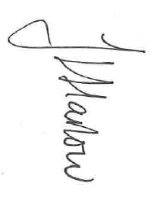
Ms J Harlow
Headteacher

