05 October 2020

Dear parent / guardian

I am writing to inform you that I have received notification today that another Merrill Academy student has tested positive for COVID-19.

As on the previous occasion, I have followed Department for Education guidance and taken advice from the Local Health Protection Team. The student is in Year 10, and has not attended school since the morning of Friday 25th September. The public health professionals have confirmed that as it has now been 13 days since the student would have been symptomatic, no further action is required.

The school will be open tomorrow to all year groups. Please can I take this opportunity to thank you all for again your support in ensuring that your child is following the guidance, including hand washing and the use of face coverings in communal areas. My colleagues and I continue to be impressed by the safe and responsible approach that students are taking to our new expectations.

If you need further information about COVID-19 symptoms, how to book a test or the latest guidance on keeping safe, this can be found at www.nhs.uk/conditions/coronavirus-covid-19/

Yours sincerely

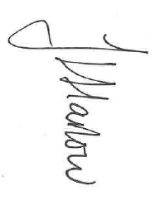
Ms J Harlow
Headteacher

