Follow us: @MerrillAcademy **Summer 2020 Issue: 1**

**MERRILL ACADEMY - Northworthy Trust**

**Newsletter**

Dates for your diary…

|  |  |
| --- | --- |
| Date | Event |
| 02/09/20 | Inset day 1 |
| 23/10/20 | Inset day 2 |
| 26-30 Oct | **Half term** |
| 21 Dec- 01 Jan | **Christmas** |
| 04/01/21 | Inset day 3 |
| 15-19 Feb | **Half term** |
| 01/04/21 | Inset day 4 |
| 02/04/21 | **Good Friday** |
| 05 – 16 April | **Easter** |
| 31 May – 4 June | **Half term** |
| 22/07/21 | Inset day 5 |
| 23/07/21 | **Summer holidays begin** |

**Message from the Headteacher**

My first year as Merrill’s new Headteacher has certainly been eventful and not one I could have ever possibly imagined. I have been overwhelmed by the support from our parents and carers this term, which has been much appreciated by the staff here at Merrill and I thank you.

I’m looking forward to building on this in the autumn term.

I am proud of what we have provided for our community since March 20th when Merrill Academy had to close due to coronavirus. There have been weekly food parcels to our most vulnerable and birthday sweet bags to all students, regular weekly safe and well check phone calls home, key worker and vulnerable student school which grew from 6 students at the beginning to almost 50 being taught in 5 groups, taught sessions in the core subjects for Year 10 students from June 15th and key stage 3 tutor check in sessions in July.

It’s going to be very different here in September for staff and students. A new horizontal year group system with Heads of Year is at the heart of the changes because of the need to reduce contact between different groups of students. The House system will still remain for competitions and Sports Day.

The **Heads of Year** will be

Miss Hughes Head of Year 7

Miss Barron Head of Year 8

Mr Foster Head of Year 9

Mr New Head of Year 10

Mrs Cameron Head of Year 11

Miss Thomas will also be taking over from Mr Foster as our Student Engagement Team Manager

Have an enjoyable summer break but remember to take care and stay safe

Miss Harlow

Headteacher



Welcome to Merrill:

Goodbye and good luck:

We will be saying goodbye to the following staff at the end of this term:

**Miss R Warrington**

**Mr C Sherratt**

**Mr E Nkamta**

**Mr T Mushiyi**

**Mrs K Page**

**Mrs V Marciano**

**Mr J Allinson**

**Mr G Quick**

**Mr E Tatabod**

*Special thanks to: Mr Quick who has been at Merrill for a number of years as Head of MFL and has been a dedicated member of the team, and organised the yearly trips to France.*

*Mrs Page who has represented the academy in Literacy programmes across the city and again, has been a dedicated member of the staff team.*

At Easter we welcomed the following new staff:

**Mrs S Blood – Teacher of Art**

**Miss S Dhiri-Harrsison – Teacher PE/Sport**

**Mrs D Illston – Mental health Lead (June 2020)**

In September we will look forward to welcoming the following new staff:

**Mrs D Flaherty - Deputy Head of Faculty (English)**

**Mrs S Dinwiddie - Teacher of Humanities**

**Mr J Wall - Teacher of Humanities**

**Mrs L Asher - Teacher of Humanities**

**Mr C Hill - Lead Practitioner of Science**

**Mr N Kennedy - Lead Practitioner of English**

**Mrs L Kanellis – Teacher of RE and English**

**Mr A Jama – Teacher of Maths**

**Mrs L Murungi – Teacher of English**

**Miss G Foster – Teacher of Science**

RE and English

**Start of term arrangements September 2020**

By now you should have received an individual letter for your child/ren detailing the days they will return to school on in September.

As explained there will be a staggered start to the year to allow us to test the year group ‘bubbles’.

If you have misplaced your letter? Copies are available on our website along with lots of useful information on how to look after your wellbeing and stay safe over the summer.

<https://www.merrillacademy.derby.sch.uk/coronavirus-covid-19>

<https://www.merrillacademy.derby.sch.uk/learning-support/safeguarding-at-merrill-academy>

<https://www.merrillacademy.derby.sch.uk/parents-carers/letter-to-parents>



**CASHLESS PAYMENT FOR LUNCHES**

Are you fed up looking for change in the morning?

Is your child fed up queuing to top up their balance to pay for lunch?

The good news is that from September you will be able to top their account up online from the comfort of your home.

A letter will be sent home shortly with details of how to do this using **SIMS Pay**.

**Grown out of your blazer? Lost your school tie?**

School uniform can be purchased from the Clothing4 Schools either online or via their local shop

General uniform: <https://clothing4schools.com/292-merrill-academy>

Year 7 Sept 2020 free blazer and tie:

<https://clothing4schools.com/333-merrill-academy-year-7-blazer-tie>

* Clothing4 Schools Chellaston
* 22A High Street, Chellaston, Derbyshire, DE73 6TD. United Kingdom
* Call us now: +44 (0)1332 321624



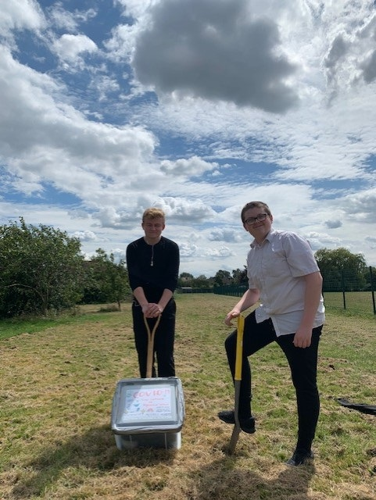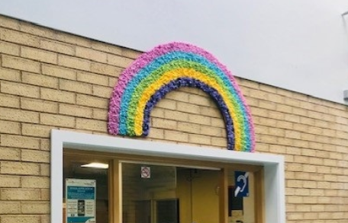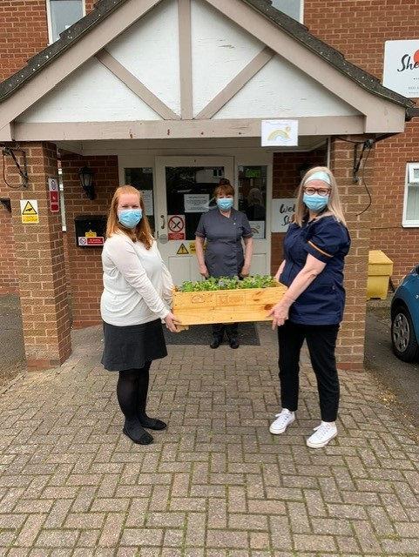**Key Worker School Highlights**

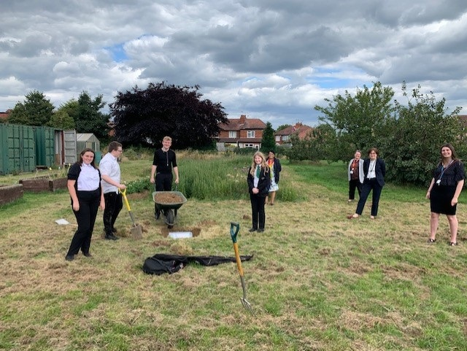

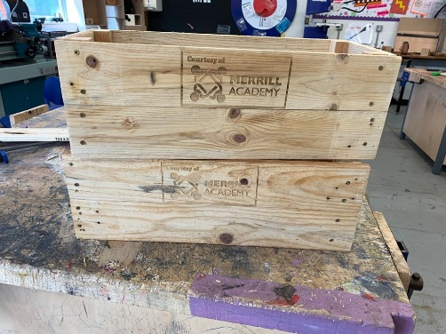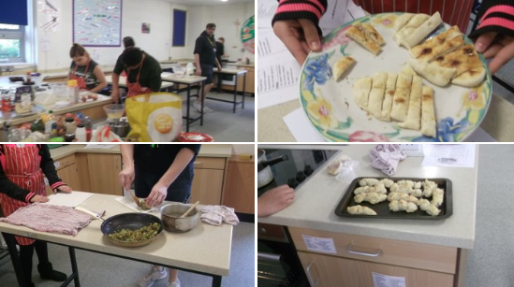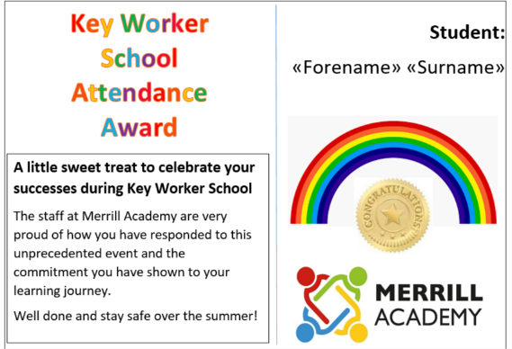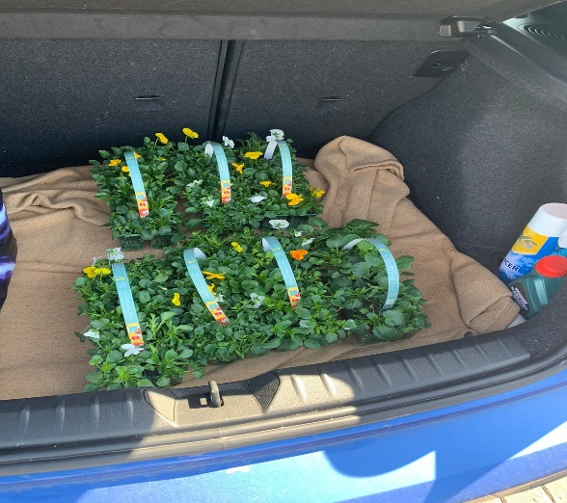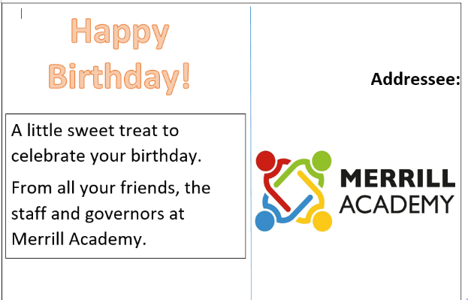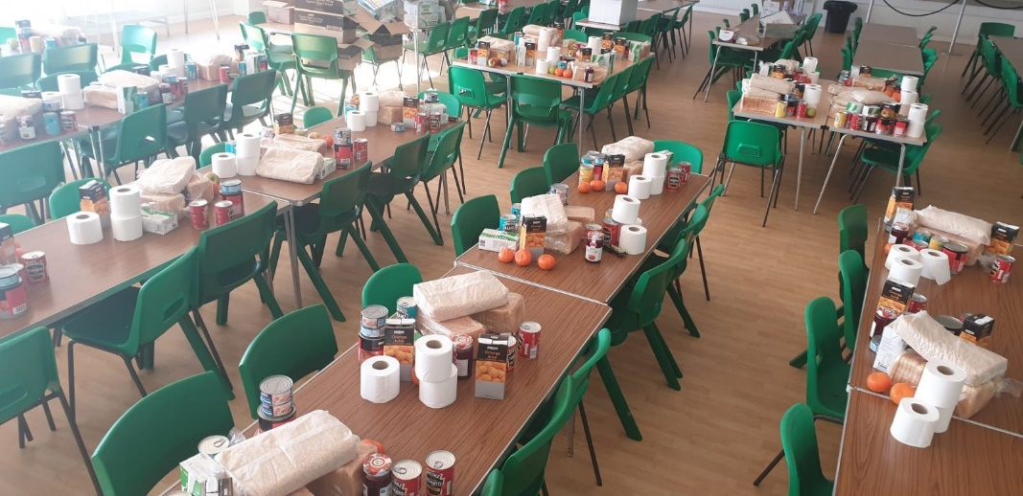

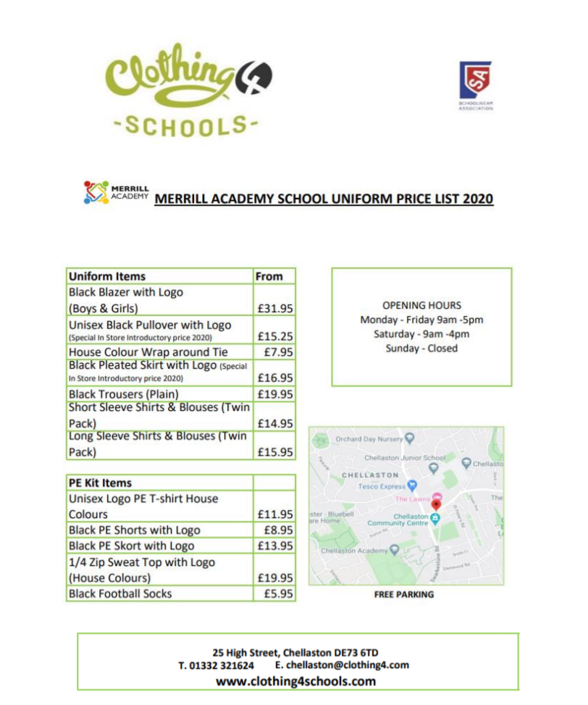

**Not available until January 2021**