19 November 2020

Dear Parents/Carers

Unfortunately, we are in the position where we have to close the school to Year 8 due to staff absence.

This means that all students in Year 8 (but not those in the Hive, Hub or Haven) will work from home on Friday 20th November. It is our intention that students may return to school on Monday 23rd November 2020, but we will inform you if the situation changes.

Our priority is to have students in school and safe. However, where staffing levels could compromise student safety, we must ask groups of students to work from home.

Work for Year 8 students will be arranged remotely during this time and your child will receive further instructions on how to access their lessons and work via their school email account.
Students who require a Free School Meal packed lunch may collect one from the front of the academy reception between 12.05 – 12.20pm. Please phone us on 01332 576777 by 9.00am on Friday to arrange this.
The school remains open for years 7, 9 and 10 and your child/ren should continue to attend if they remain well (Year 11 should continue to stay at home and complete their period of self-isolation, returning next Tuesday).

At all times, the safety of our students, staff and wider community is our number one priority. We will continue to keep you updated via all communication channels. Thank you for your continued support.

Please ensure we have your correct contact details so you are kept informed.

Yours faithfully

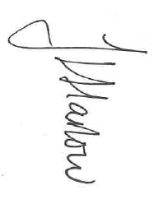
Ms J Harlow
Headteacher

