25 June 2020

Dear Parent/Carer

Quite a few parent/carers have contacted the academy asking about the uniform requirements for September 2020 because at the moment it’s slightly different in key worker and Year 10 school.

The expectation is that in September all students will return in full uniform, including blazers, ties and school shoes.

We have also introduced two new items of uniform that can now be purchased from our uniform shop. These are a school skirt and school jumper both with the academy logo on. Because of the current situation and individual circumstances, they will now not become compulsory until January 2021, for students who choose to wear a skirt or jumper with their blazer.

Our new logo PE kit will not yet be available to purchase until after the Christmas break at the earliest. This is due to the factories being closed.

As detailed in my letter earlier this year, as of September 2020 students will also not be permitted to have unnaturally dyed hair colours or multiple piercings. This is in line with all other schools across the city.

Further information regarding the new term will follow shortly. However, current plans are as follows:

- Year 7 will be starting back on Thursday 3rd September. This will be their transition day and they will be the only year in school. Parents and carers have been informed.

- Year 7 and Year 11 only with be in on Friday 4th September, with slightly staggered arrival times. Details to follow.

- Year groups 8-10 will start back week beginning 7th September, again this will be staggered. Further details to follow shortly, once we have received further government guidance

Thank you for your continued support with your child’s learning at home.

Yours sincerely

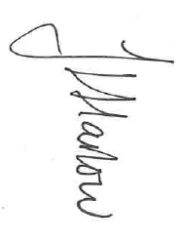
Ms J Harlow
Headteacher

